Lab Report

Your Information
Your Name: Josh Zimmerman-Gibson
Assignment Title: 1.4 MongoDB Data Handling

Screenshots
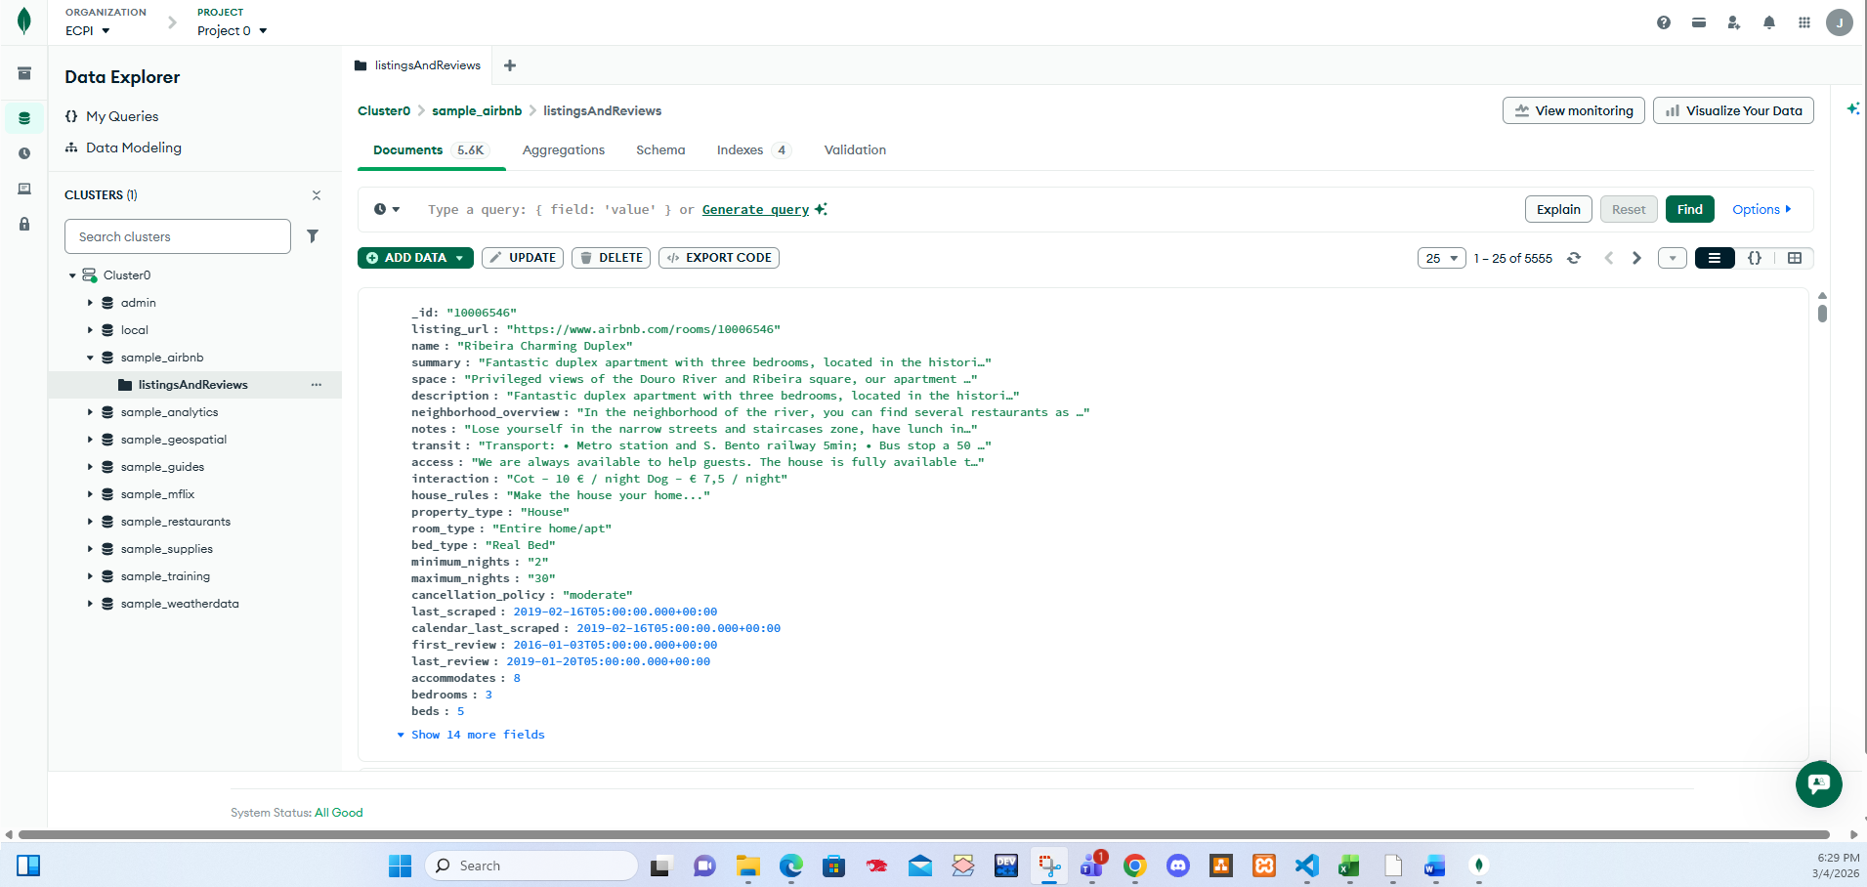
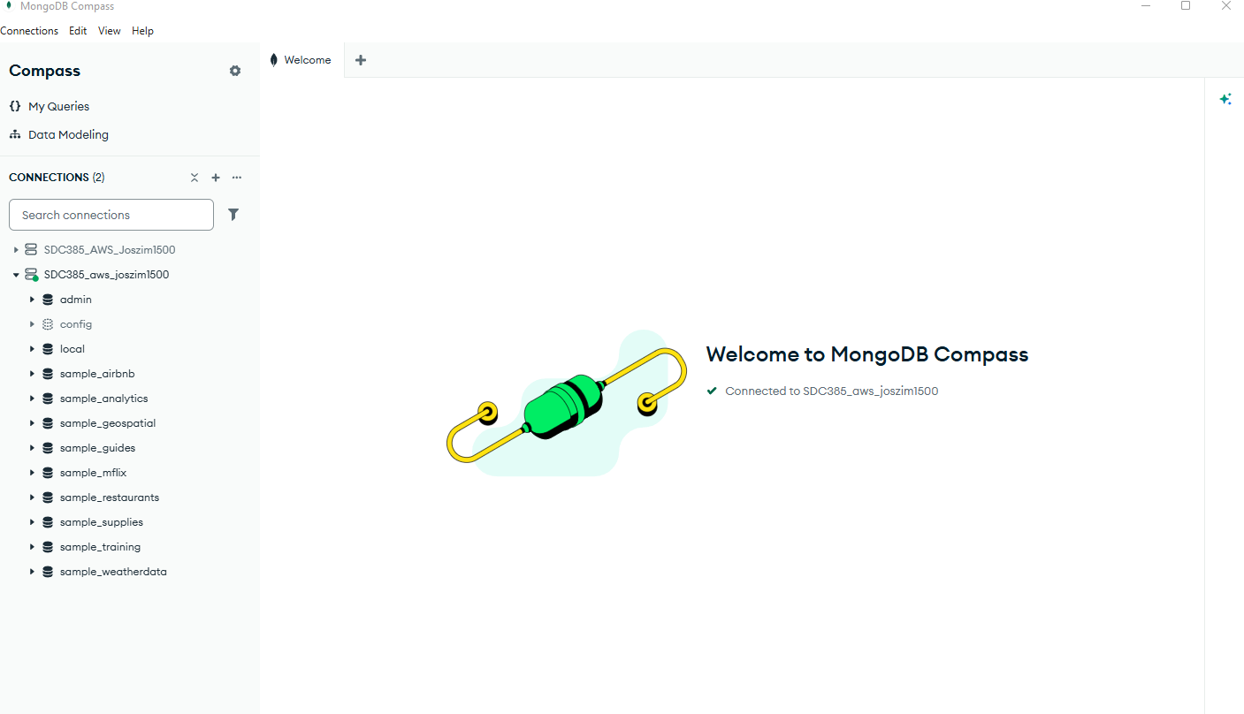
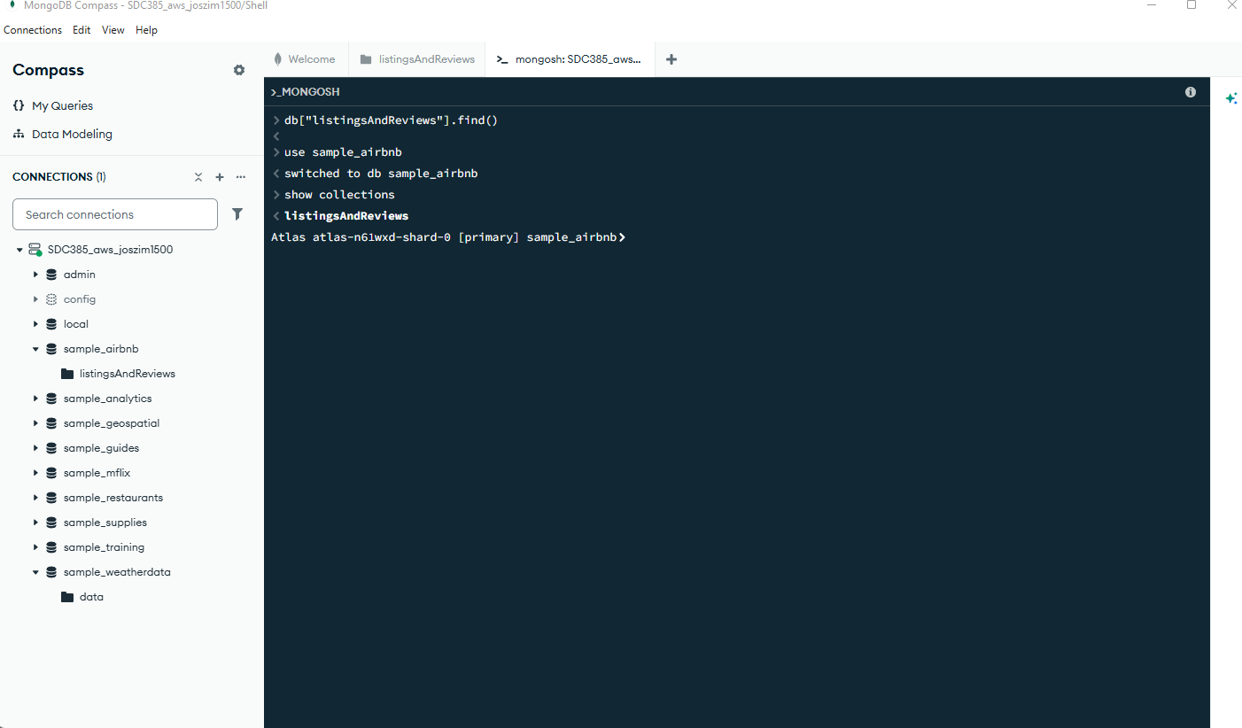
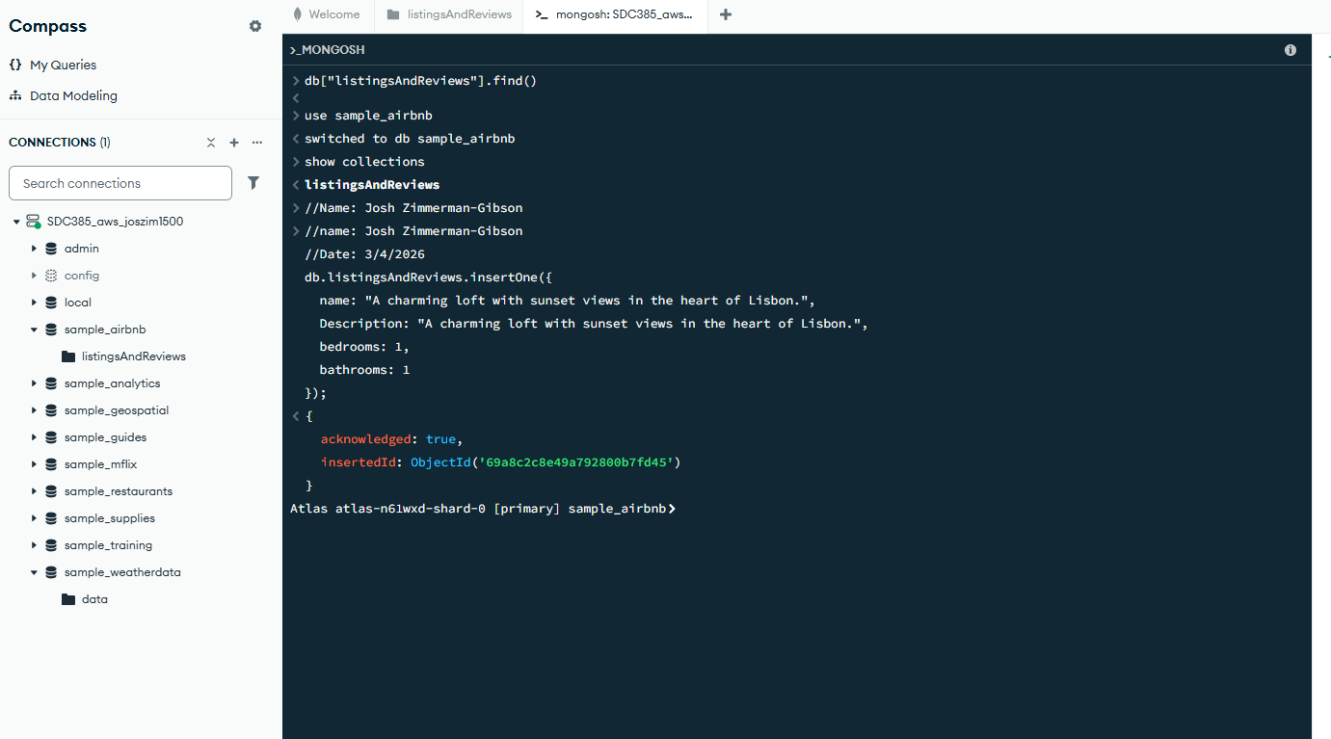
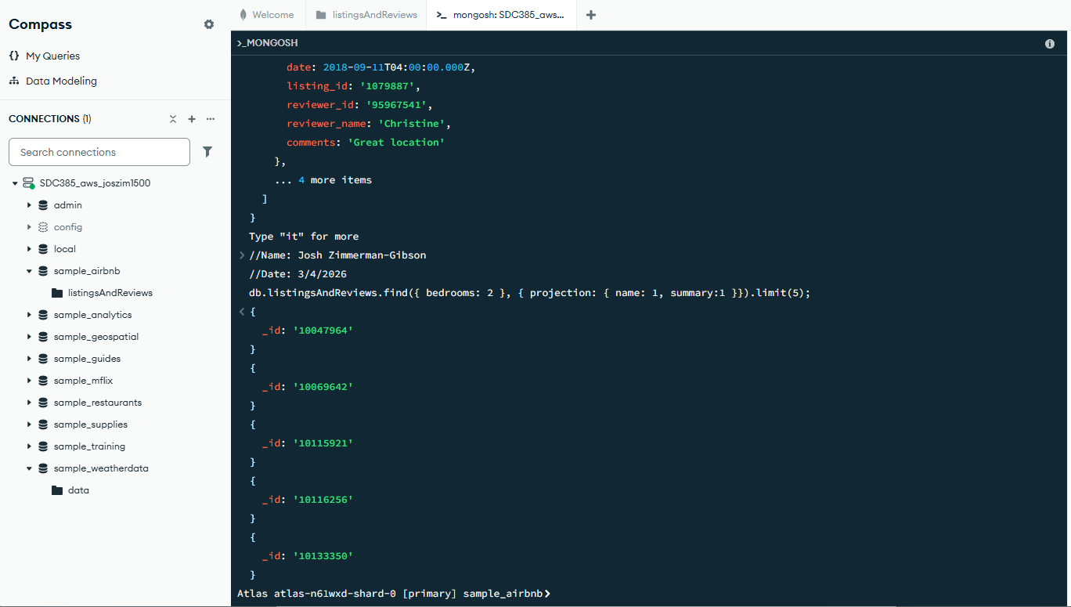
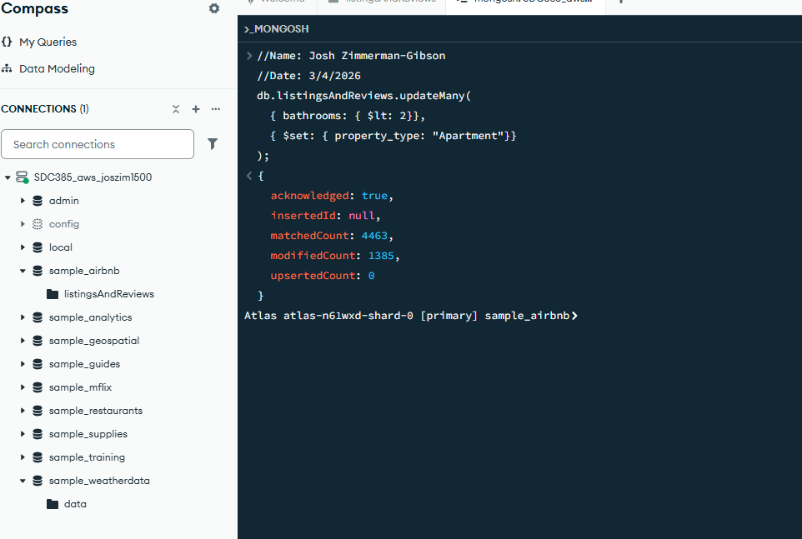
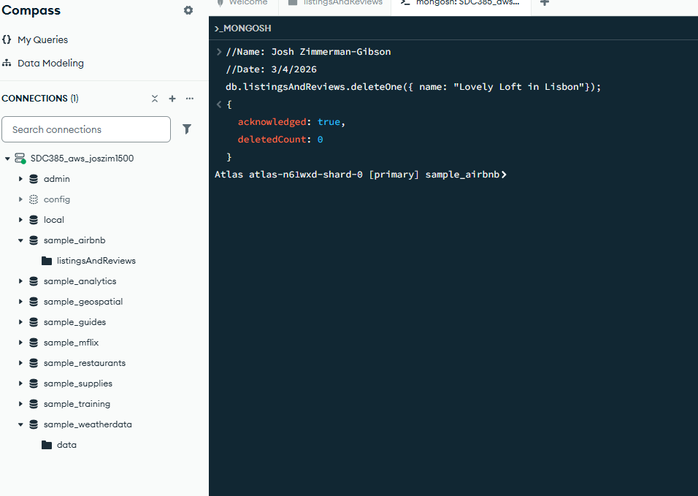
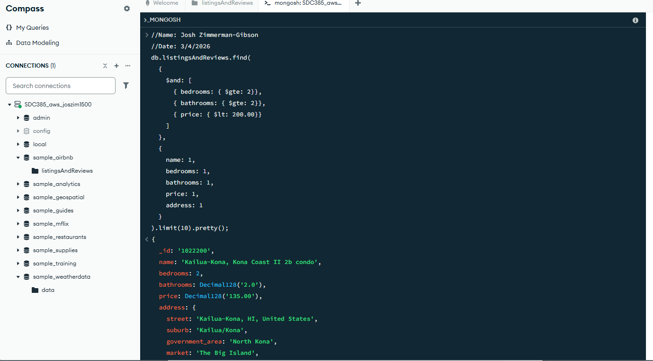
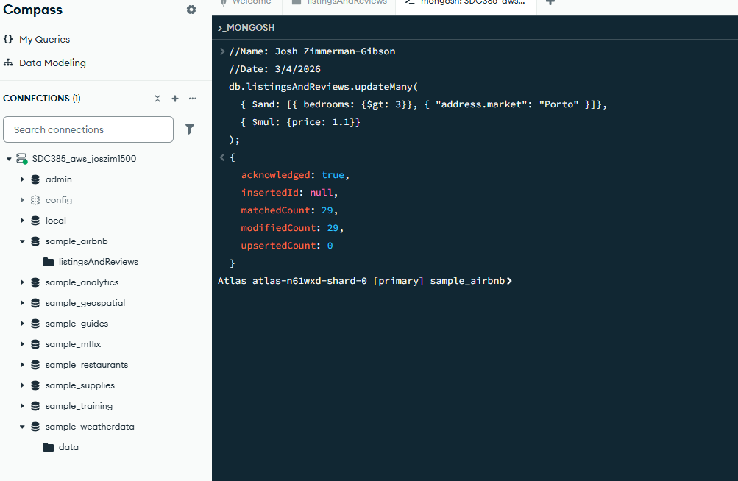
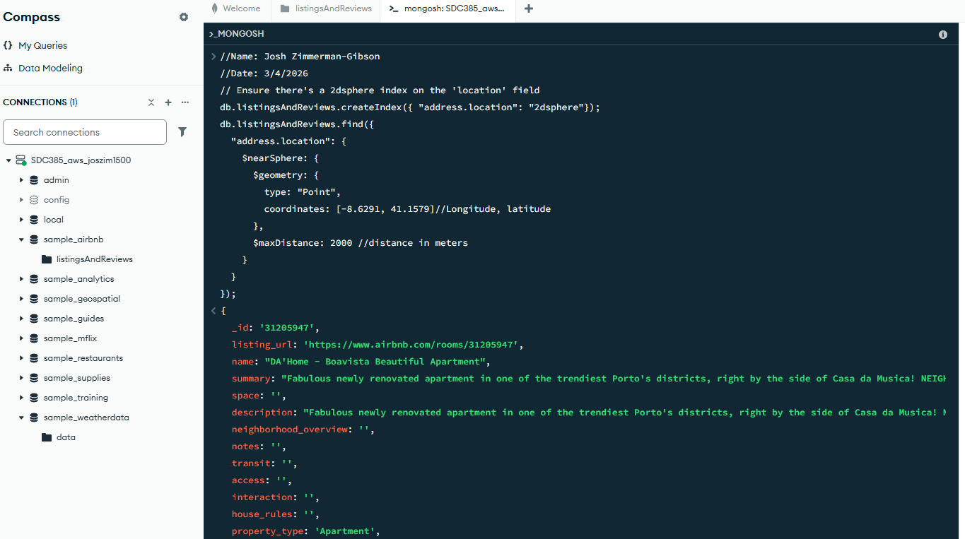
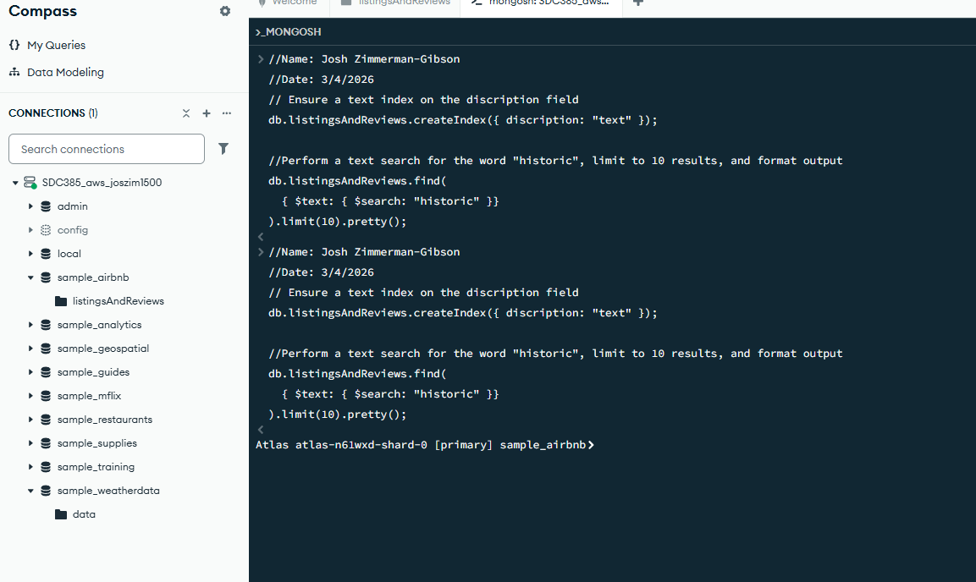
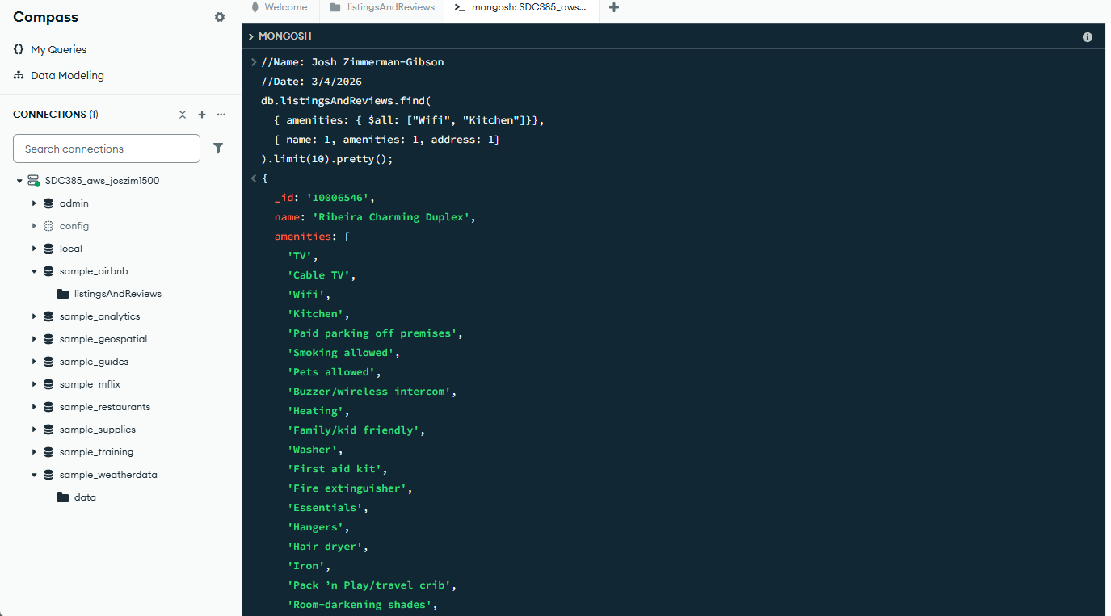
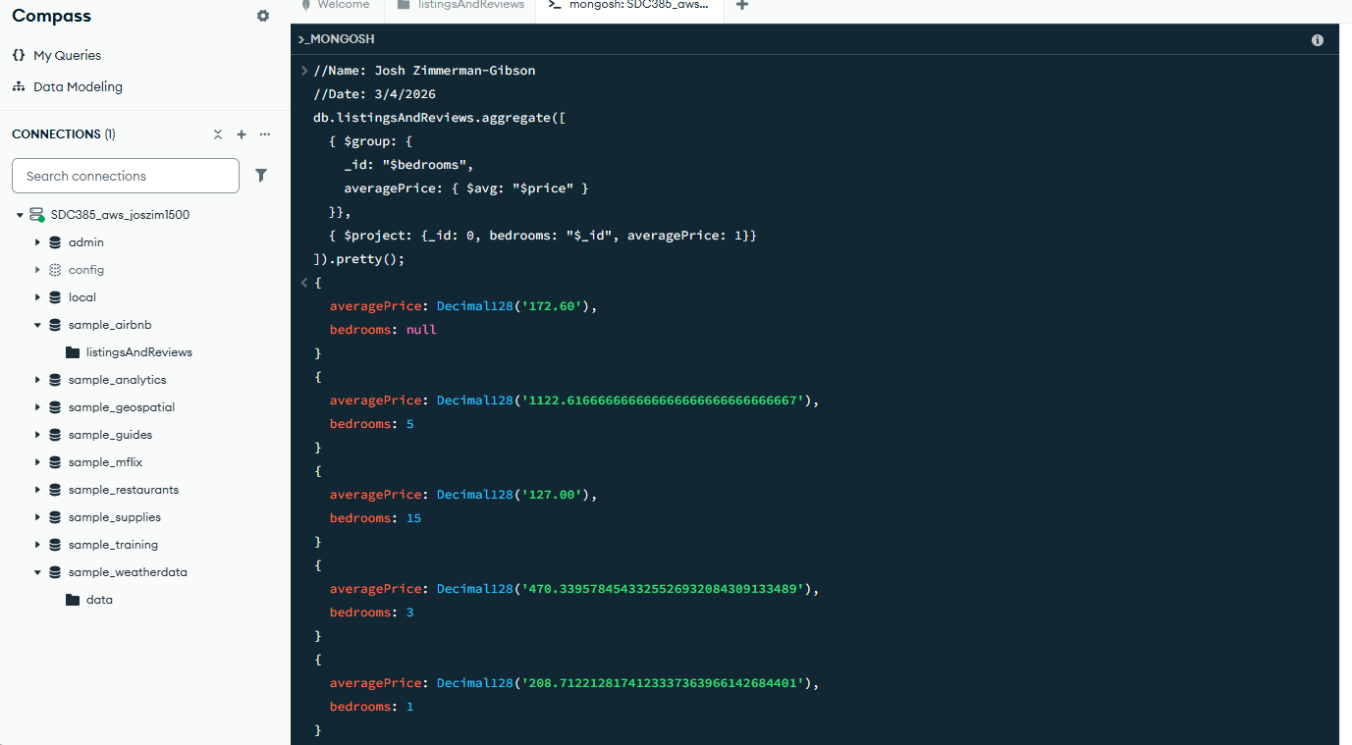
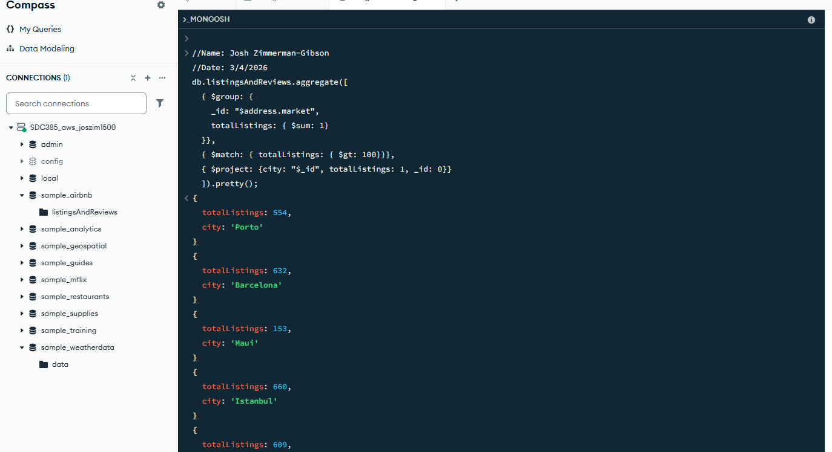
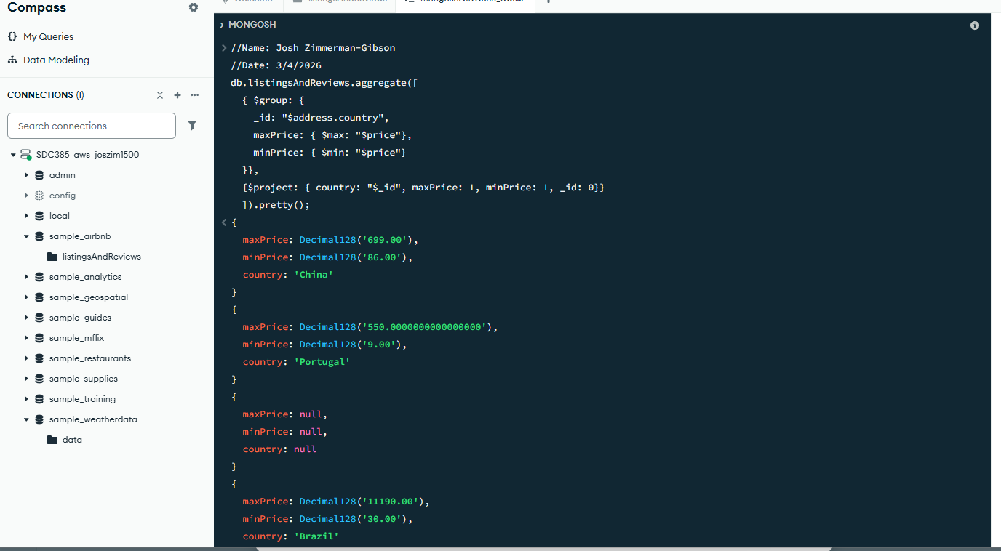
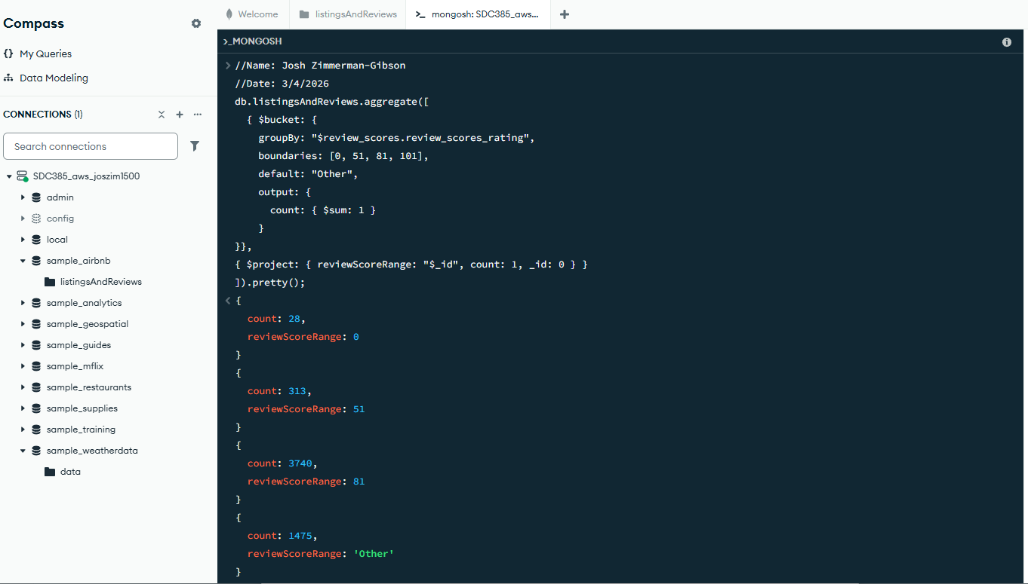
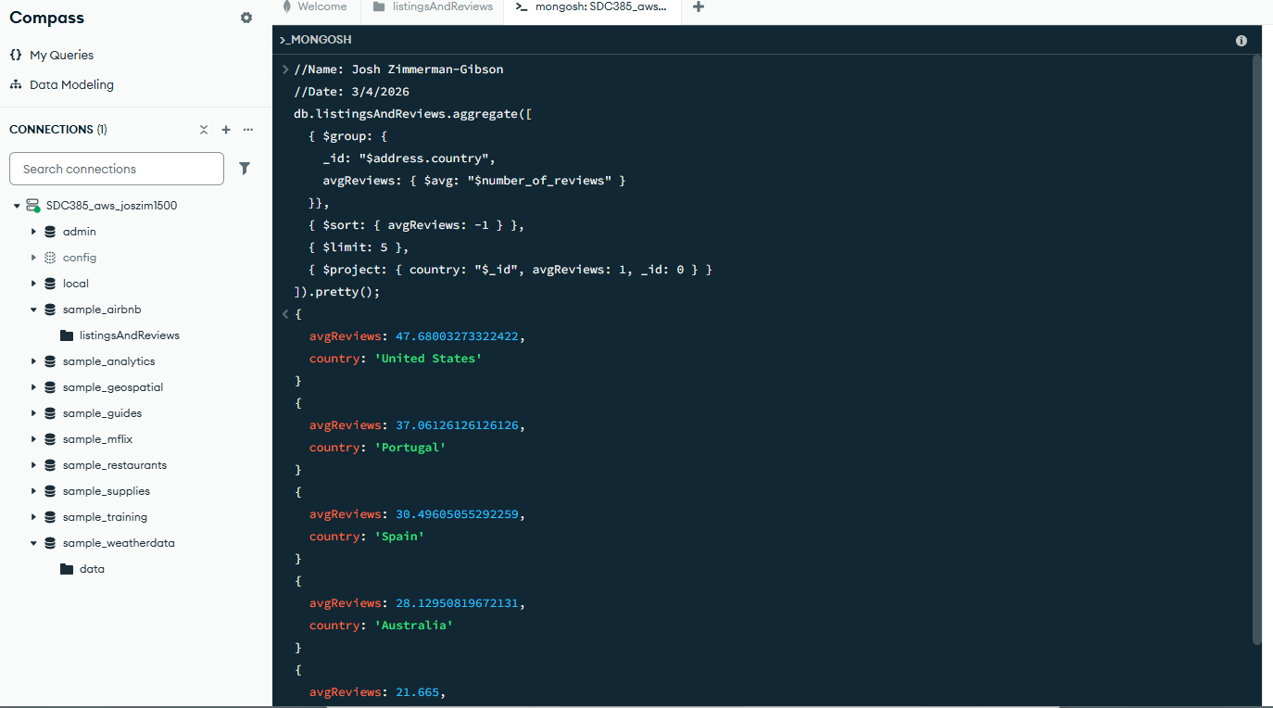

Questions

1. Can you explain the difference between the $group and $project operators in MongoDB's
aggregation pipeline?
$group = combines multiple documents into summary documents.
$project = transforms each document individually.

2. How does MongoDB handle geospatial queries, and why is the creation of a 2dsphere index
important for these queries?
MongoDB supports geospatial data using:
- GeoJSON objects (e.g., points, polygons, lines)
- Geospatial query operators such as:
  - $near, $geoWithin, $geoIntersects
These allow MongoDB to answer questions like:
- “Which restaurants are within 3 miles of me?”
- “Which points fall inside this polygon?”
A 2dsphere index enables MongoDB to:
- Efficiently compute spherical geometry (Earth-like curvature).
- Perform accurate geospatial calculations using latitude/longitude.
- Speed up queries massively—without it, geospatial queries may fail or require full collection scans.

3. Why is text indexing necessary for full-text search in MongoDB, and how does it differ from
standard field value queries?
A text index allows MongoDB to perform:
- Full-text search
- Relevance scoring
- Tokenization and stemming
(e.g., “running” matches “run”)
Normal indexes cannot provide these capabilities.
